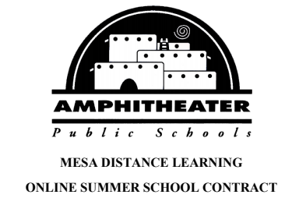

**MESA DISTANCE LEARNING**

**ONLINE SUMMER SCHOOL CONTRACT**

As a student of the Amphitheater School District’s online program, I.       (Student’s Full Name), understand and agree to abide by the requirements for enrollment listed below.

* Students must be enrolled in the Amphitheater School District and have completed enrollment paperwork with their home school.
* The official enrollment start date for online summer school will be **May 22, 2023.**
* A student who has not completed **20%** of the course by the **29th** **day from the initial enrollment date** will be automatically dropped.
* A student who has completed 20% or more of a course and either drops or does not finish the course will receive an “F”, regardless of when the 20% was completed. The final course grade will be posted on the student’s transcript.
* Students must demonstrate academic integrity at all times. A student who is determined to have violated Amphitheater School District’s policy on academic dishonesty *may* lose credit for the course.
* Students will be given the opportunity to earn up to 1.0 transferable credit *or* two semesters of coursework.

**Note:**

* + All coursework, including the final exam, **must be completed** by the final deadline of **July 13, 2023.** If a student wishes to complete two semesters of coursework, a second course may begin at the conclusion of the first course but not *after* **June 22, 2023.**
  + Students may only take one semester course at a time.
* Online teachers grade and provide feedback within an average time of 24 hours. Plan accordingly. All online coursework must be submitted and graded *before* approval is given to complete the final exam.
* Recommended pacing for a semester-long course is approximately six hour per day; five days per week.
* Any course taken to replace a grade from a previously taken course, must be the same course/course number. Please see your counselor or an administrator to confirm that you are enrolling in the correct course.
* **All MDLP courses require a final exam to be given by the online teacher, in person.** The student must make arrangements with their school administrator to take the test at school.

The alternative version of this final exam consists of performance and discussion-based assessments. The performance portion can be completed at home, while the discussion portion will be completed with your teacher via video conferencing software.

* **Cost: There is no charge for current Amphitheater School District students.**

|  |  |  |  |  |  |  |
| --- | --- | --- | --- | --- | --- | --- |
|  | **Dates:** | **Course Name(s):** | **Course Number(s):** | | | **Semester of Course:** |
| **1st Course** | May 22 – June 22 |  |  | | | 1st or  2nd Semester |
| **2nd Course** | June 22 – July 13 |  |  | | | 1st or  2nd Semester |
| Please indicate in the following box if your student is an NCAA athlete. | | | |  |
| If your student has an IEP or 504, please check the following box. | | | |  |

|  |  |  |
| --- | --- | --- |
|  |  |  |
| Student Signature | Student School ID # | Date |
|  |  |  |
|  |  |  |
| Parent/Guardian Signature |  | Date |